Inheritance means one class get the attributes and methods directly from another class without repeating typing them. It is like the child class inherit the characteristics from its parent class. The child class shares the common attributes and methods with its parent class. Meanwhile, the child class can develop its own attributes and methods apart from its parent class.

One of the benefits of inheritance in programming is to reduce the same code lines for the classes that share the same attributes and methods. For those that share the same attributes and methods, they can organize them to the base class so that the child classes can inherit the parent class without typing the same code.

Supposed we have math assignments and writing assignments. Both of them need to contain the student’s name and the topic. What’s different between them is that the textbook section and the problems are included in math assignments while title is included in writing assignment. As for the methods, both assignments share one common method called GetSummary; however, GetHomeworkList is shown in math assignment while GetWritingInformation is shown in writing assignment. In this case, we can create a base class called Assignment so the attributes called _studnetName and _topic and the method called GetSummary() can be placed here. Attributes called _textbookSection and _problems and a method called GetHomeworkList() are placed in MathAssignment class. An attribute called _title and a method called GetWritingInformation are placed in Writing Assignment.

In the project of Mindfulness, the base class called Activity contains attributes called _activityName and _description and methods called GetWelcomeMessage(), GetDescription(), GetDuration(), Ready(), and EndMessage(). These attributes and methods are shared by Breathing Activity, Reflecting Activity and Listing Activity. However, these three child classes have their own methods too. For their separate methods, we have to write them down in different classes. 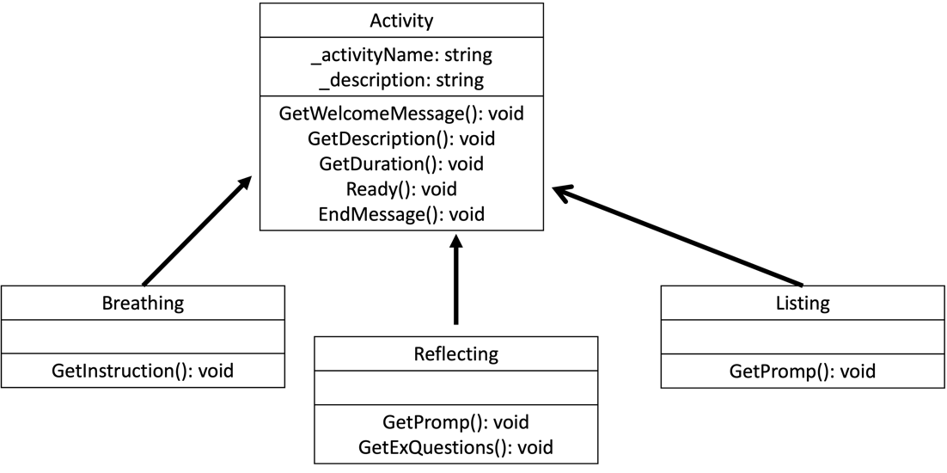

public class Activity

{

protected string _activityName = "";

protected string _description = "";

public void GetWelcomeMesssage()

{

Rest of the code...

}

public void GetDescription()

{

Rest of the code...

}

public void GetDuration()

{

Rest of the code...

}

public void Ready()

{

Rest of the code...

}

public void EndMessage(int activityTime)

{

Rest of the code...

}

Rest of the code...

}

public class Breathing : Activity

{

public Breathing() : base("Breathing", "This activity will help you relax by walking you through breathing in and out slowly. Clear your mind and focus on your breathing.")

{}

public void GetInstruction(int activityTime)

{

Rest of the code...

}

Rest of the code...

}

public class Reflecting : Activity

{

public Reflecting() : base("Reflecting", "This activity will help you reflect on times in your life when you have shown strength and resilience. This will help you recognize the power you have and how you can use it in other aspects of your life.")

{}

public void GetPrompt()

{

Rest of the code...

}

public void GetExQuestions(int activityTime)

{

Rest of the code...

}

}

public class Listing : Activity

{

public Listing() : base ("Listing", "This activity will help you reflect on the good things in your life by having you list as many things as you can in a certain area.")

{}

public void GetPrompt(int activityTime)

{

Rest of the code...

}

}